**Software Engineering Biography – David Cutler**

David Cutler, born and raised in Michigan, is best known for his work on the revolutionary Windows operating systems, namely Windows NT. Windows NT has gone on to be the basis of every major Windows operating system since 1993. A member of the National Academy of Engineering and awarded the US National Medal of Technology and Innovation by President Bush in 2007, Cutler is an extremely renowned and gifted software engineer and pioneer in the field.

**Early Life and Education**

Cutler was born in Michigan in 1942. After being awarded an academic and athletic scholarship to the private and Christian college, Olivet College, he graduated in 1965. He studied mathematics and physics.

**Career Beginnings**

He had an “overwhelming desire to be an engineer and build things” so he began working for DuPont after college. After what Cutler describes as a “year of boredom” he, by chance, ended up working on computer simulations and it was through this experience he became hooked on computers. He soon transferred to DuPont’s engineering department where he got his beginnings in writing application code and central control programs. He realised though that the only way he was going to get the opportunity to implement an operating system, as he desired, was by working for a company who made computers. In 1971 he left DuPont and joined Digital Equipment Corporation (DEC).

**First Operating Systems**

At DEC, Cutler’s first project was to create an operating system called RSX-11M which were to run on DEC’s PDP-11, 16-bit minicomputers. Cutler recalls that for the time his team’s goals were “very ambitious”. Cutler recalls how he was very set on instilling, in his team, the importance of achieving their goals, even going so far on having a stamp made, which he used to stamp all correspondence with the phrase “Size is the Goal”. Cutler will admit that while the RSX-11M OS had size and performance constraints, ultimately it was the easiest he has worked on. The development of this device would also make it easier for the development of PDP-11 which was the most popular microcomputer of its time.

As computer architectures were becoming obsolete due to their limited address bits there was a need for a new architecture on the market, which led to the development of VAX, which had 32-bits of virtual address space. On the new VAX architecture Cutler got his second opportunity to work on operating systems. Cutler recalls that he believes his biggest mistake made on the development of this new operating system was not using high level language. Instead, the team he was working with was made up of some very experienced and talented assembly language programmers and due to time constraints, he made the decision to have the team develop the operating system in a reliable and familiar language. Cutler will recall now that the moral of this story is that “The right thing to do technically isn't always the best thing to do financially”, which is something that software developers must be aware of.

**Microsoft**

Cutler recalls that he received an “interesting” call from Bill Gates at Microsoft in the summer of 1988. Gates approached Cutler with the idea of developing an operating system for personal computers at Microsoft. He wanted to create an operating system that was portable and allowed companies and individuals to complete crucial tasks on their PCs. Cutler says that he wasn’t too interested in working on PCs, but he was always interested in the thought of working on operating systems. With that, Cutler left DEC and joined Microsoft to join the team that would begin work on what would be the Windows-NT, an operating system that would be a pioneer in the field and be the basis of nearly all Windows operating systems for nearly 30 years.

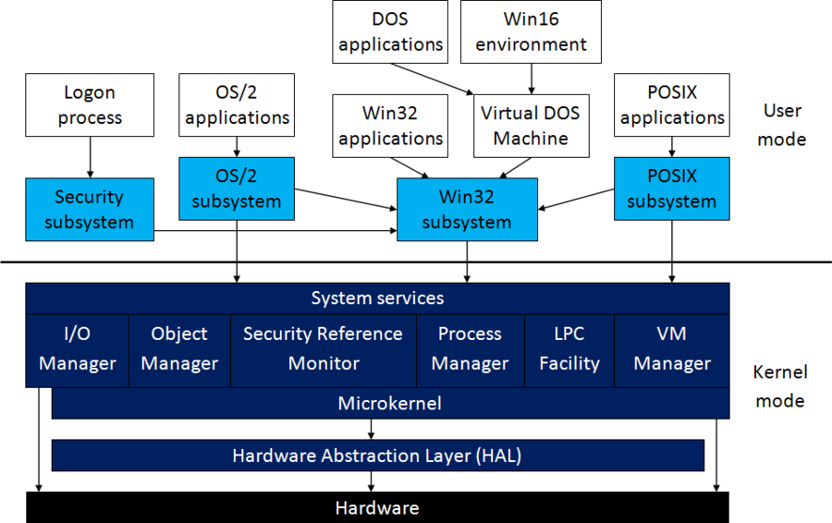The team at Microsoft had a few main objectives for what would be the Windows-NT. Portability, security, compatibility, scalability, extensibility, and ease of internationalisation were the main goals. Cutler recalls that the hardest of these goals to achieve was the compatibility. Millions of personal computers were being sold. After four years, they were ready to release Windows-NT. During the course of development, 250 programmers wrote 5.6 million lines of code and fixed 30,000 bugs in the final year of production alone.

Architecture of Windows NT 3.1

Although the system’s success was only moderate as the hardware requirements were very high for the time, the system had a lasting and strong impact. Microsoft would unify the Windows line with the Windows NT line in 2001 when they released Windows XP which would go on to become the most widely used operating system until Windows 7 took over in 2012.

Dave Cutler would be awarded Microsoft’s prestigious Senior Technical Fellow role. He continued to work with the Microsoft Azure team on cloud computing and later the Xbox One console. Cutler is an extremely gifted software engineer and a pioneer in operating systems field. He now lives in Medina, Washington with his long-time partner. He enjoys golfing and skiing and can still be found at Microsoft on the weekends.